**21CY681 - INTERNET PROTOCOL LAB - 11**

Name: Akhil K J

Register Number: CB.EN.P2CYS22009

Date: 26/12/2022

Assignment Topic: Application of Cryptogrpahical Algorithms using Socket programming

First we create a python program for a server for a connection to a client using RSA encryption key.

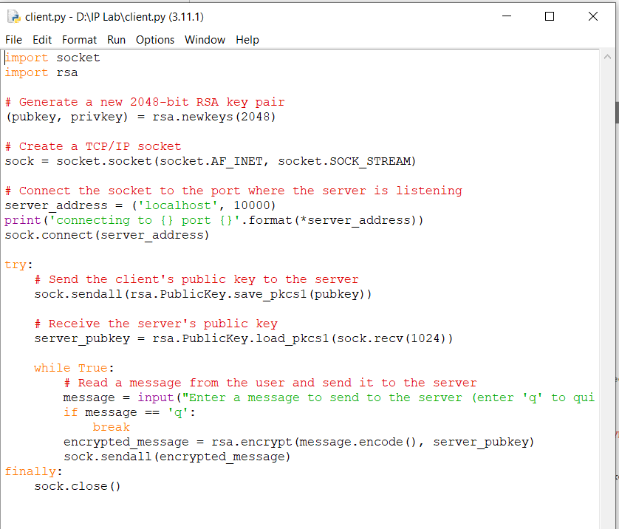

Now, let us write a python program for client which communicates with the server using RSA encryption.

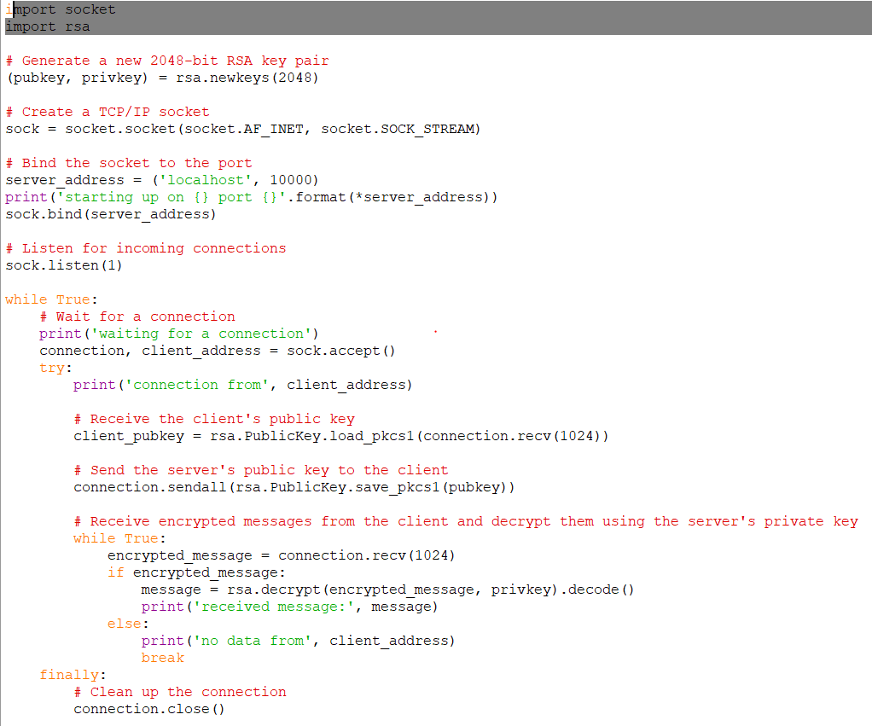

The screenshot shows that the client has been connected to the server and is sending a message to the server.

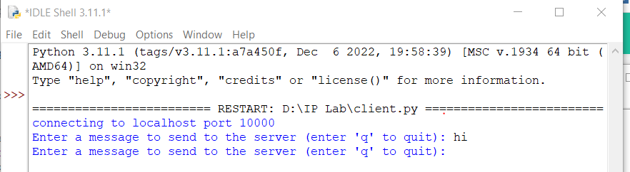

The screenshot shows the output of the server where it has got a connection from the client and receives a message hi sent by the client.

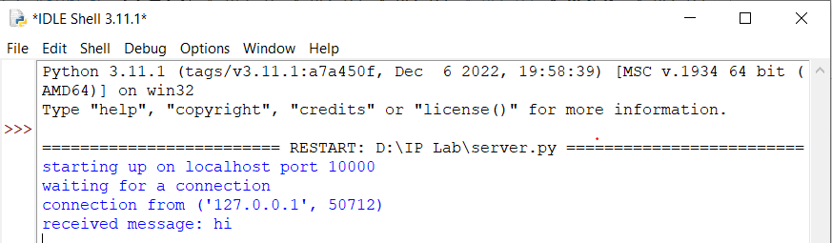

Now we capture these connection traffic using loopback in Wireshark. Now if we search the TCP packets captured, we get the data being transferred.



